Coronavirus disease 2019 (COVID-19)
Situation Report – 36

Data as reported by 10AM CET 25 February 2020*

HIGHLIGHTS

- Four new Member States (Afghanistan, Bahrain, Iraq, and Oman) reported cases of COVID-19 in the past 24 hours.

- For healthcare workers and public health professionals, WHO has an online course titled Infection Prevention and Control (IPC) for Novel Coronavirus (COVID-19). You can access the course through the following link: https://openwho.org/courses/COVID-19-IPC-EN. This course provides information on what facilities should be doing to prepare to respond to a case of an emerging respiratory virus such as the novel coronavirus.

- The WHO-China joint mission concluded on 24 February. The team has made a range of findings about the transmissibility of the virus, the severity of disease and the impact of the measures taken. Please see here for more information regarding the findings of the mission.

- A joint WHO and European Centre for Disease Prevention and Control (ECDC) mission arrived in Italy on 24 February to support Italian authorities on the COVID-19 situation. More information can be found here.

SITUATION IN NUMBERS
total and new cases in last 24 hours

Globally
80 239 confirmed (908 new)

China
77 780 confirmed (518 new)
2666 deaths (71 new)

Outside of China
2459 confirmed (390 new)
33 countries (4 new)
34 deaths (11 new)

WHO RISK ASSESSMENT
China | Very High
Regional Level | High
Global Level | High

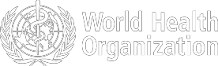

Figure 1. Countries, territories or areas with reported confirmed cases of COVID-19, 25 February 2020

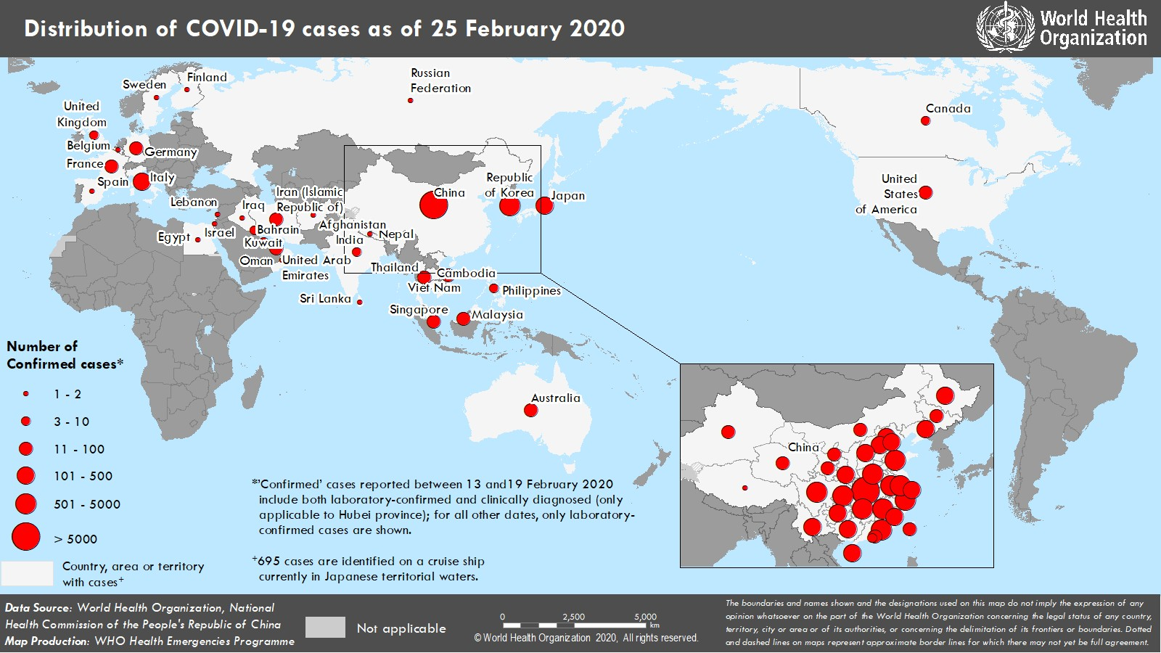

SURVEILLANCE

Table 1. Confirmed and suspected cases of COVID-19 acute respiratory disease reported by provinces, regions and cities in China, 25 February 2020
Province/ Region/ | Population (10,000s) | Confirmed | Daily Suspected |  | Cumulative  Confirmed Deaths
City | cases |  | cases | Deaths | cases
Hubei | 5917 | 499 | 373 | 68 | 64786 |  | 2563
Guangdong | 11346 | 2 | 0 | 1 | 1347 |  | 7
Henan | 9605 | 0 | 5 | 0 | 1271 |  | 19
Zhejiang | 5737 | 0 | 1 | 0 | 1205 |  | 1
Hunan | 6899 | 0 | 1 | 0 | 1016 |  | 4
Anhui | 6324 | 0 | 0 | 0 | 989 |  | 6
Jiangxi | 4648 | 0 | 0 | 0 | 934 |  | 1
Shandong | 10047 | 0 | 0 | 2 | 755 |  | 6
Jiangsu | 8051 | 0 | 0 | 0 | 631 |  | 0
Chongqing | 3102 | 1 | 13 | 0 | 576 |  | 6
Sichuan | 8341 | 2 | 7 | 0 | 529 |  | 3
Heilongjiang | 3773 | 0 | 0 | 0 | 480 |  | 12
Beijing | 2154 | 1 | 18 | 0 | 400 |  | 4
Shanghai | 2424 | 0 | 30 | 0 | 335 |  | 3
Hebei | 7556 | 0 | 0 | 0 | 311 |  | 6
Fujian | 3941 | 1 | 0 | 0 | 294 |  | 1
Guangxi | 4926 | 1 | 3 | 0 | 252 |  | 2
Shaanxi | 3864 | 0 | 0 | 0 | 245 |  | 1
Yunnan | 4830 | 0 | 9 | 0 | 174 |  | 2
Hainan | 934 | 0 | 9 | 0 | 168 |  | 5
Guizhou | 3600 | 0 | 0 | 0 | 146 |  | 2
Tianjin | 1560 | 0 | 38 | 0 | 135 |  | 3
Shanxi | 3718 | 1 | 0 | 0 | 133 |  | 0
Liaoning | 4359 | 0 | 9 | 0 | 121 |  | 1
Jilin | 2704 | 0 | 14 | 0 | 93 |  | 1
Gansu | 2637 | 0 | 0 | 0 | 91 |  | 2
Hong Kong SAR | 745 | 7 | 0 | 0 | 81 |  | 2
Xinjiang | 2487 | 0 | 0 | 0 | 76 |  | 2
Inner Mongolia | 2534 | 0 | 0 | 0 | 75 |  | 0
Ningxia | 688 | 0 | 0 | 0 | 71 |  | 0
Taipei and environs | 2359 | 3 | 0 | 0 | 31 |  | 1
Qinghai | 603 | 0 | 0 | 0 | 18 |  | 0
Macao SAR | 66 | 0 | 0 | 0 | 10 |  | 0
Xizang | 344 | 0 | 0 | 0 | 1 |  | 0
Total | 142823 | 518 | 530 | 71 | 77780 |  | 2666

Table 2. Countries, territories or areas outside China with reported laboratory-confirmed COVID-19 cases and deaths. Data as of 25 February 2020

Likely place of exposure‡
Outside In
†

Total cases with site of

Total

Country/Territory/Area Confirmed
cases (new)

Western Pacific Region
Republic of Korea 977 (214)
Japan 157 (13)
Singapore 90 (1)
Australia 22 (0)
Malaysia 22 (0)
Viet Nam 16 (0)
Philippines 3 (0)
Cambodia 1 (0)
South-East Asia Region
Thailand 37 (2)
India 3 (0)
Nepal 1 (0)
Sri Lanka 1 (0)
Region of the Americas
United States of America 53 (18)
Canada 10 (1)
European Region
Italy 229 (105)
Germany 16 (0)
France 12 (0)
The United Kingdom* 13 (0)
Israel 2 (1)
Russian Federation 2 (0)
Spain 2 (0)
Belgium 1 (0)
Finland 1 (0)
Sweden 1 (0)
Eastern Mediterranean Region
Iran (Islamic Republic of) 61 (18)
United Arab Emirates 13 (0)
Bahrain 8 (8)
Kuwait 8 (5)
Oman 2 (2)
Afghanistan 1 (1)
Egypt 1 (0)
Iraq 1 (1)
Lebanon 1 (0)
Subtotal for all regions 1768 (390)
International conveyance§
China (new)
reporting
country and outside China (new)
13 (0) | 4 (0) | 605 (0) | 355 (214) | 10 (3)
28 (0) | 7 (2) | 110 (3) | 12 (8) | 1 (0)
24 (0) | 0 (0) | 66 (1) | 0 (0) | 0 (0)
12 (0) | 7 (0) | 3 (0) | 0 (0) | 0 (0)
18 (0) | 2 (0) | 2 (0) | 0 (0) | 0 (0)
8 (0) | 0 (0) | 8 (0) | 0 (0) | 0 (0)
3 (0) | 0 (0) | 0 (0) | 0 (0) | 1 (0)
1 (0) | 0 (0) | 0 (0) | 0 (0) | 0 (0)
23 (0) | 0 (0) | 7 (1) | 7 (1) | 0 (0)
3 (0) | 0 (0) | 0 (0) | 0 (0) | 0 (0)
1 (0) | 0 (0) | 0 (0) | 0 (0) | 0 (0)
1 (0) | 0 (0) | 0 (0) | 0 (0) | 0 (0)
14 (0) | 36 (18) | 2 (0) | 1 (0) | 0 (0)
7 (0) | 1 (0) | 1 (0) | 1 (1) | 0 (0)
3 (0) | 0 (0) | 121 (0) | 105 (105) | 6 (4)
2 (0) | 0 (0) | 14 (0) | 0 (0) | 0 (0)
5 (0) | 0 (0) | 7 (0) | 0 (0) | 1 (0)
2 (0) | 10 (0) | 1 (0) | 0 (0) | 0 (0)
0 (0) | 2 (1) | 0 (0) | 0 (0) | 0 (0)
2 (0) | 0 (0) | 0 (0) | 0 (0) | 0 (0)
0 (0) | 2 (0) | 0 (0) | 0 (0) | 0 (0)
1 (0) | 0 (0) | 0 (0) | 0 (0) | 0 (0)
1 (0) | 0 (0) | 0 (0) | 0 (0) | 0 (0)
1 (0) | 0 (0) | 0 (0) | 0 (0) | 0 (0)
0 (0) | 0 (0) | 28 (0) | 33 (18) | 12 (4)
6 (0) | 2 (0) | 5 (0) | 0 (0) | 0 (0)
0 (0) | 8 (8) | 0 (0) | 0 (0) | 0 (0)
0 (0) | 8 (5) | 0 (0) | 0 (0) | 0 (0)
0 (0) | 2 (2) | 0 (0) | 0 (0) | 0 (0)
0 (0) | 1 (1) | 0 (0) | 0 (0) | 0 (0)
0 (0) | 0 (0) | 1 (0) | 0 (0) | 0 (0)
0 (0) | 1 (1) | 0 (0) | 0 (0) | 0 (0)
0 (0) | 1 (0) | 0 (0) | 0 (0) | 0 (0)
0 (0) | 94 (38) | 981 (5) | 514 (347) | 31 (11)
0 (0) | 0 (0) | 0 (0) | 691 (0) | 3 (0)
179 (0) | 94 (38) | 981 (5) | 1205 (347) | 34 (11)

reporting country (new)
transmission under investigation (new)
deaths (new)

(Diamond Princess)
691 (0)

Grand total 2459 (390)
†Case classifications are based on WHO case definitions for COVID-19.
‡Location of transmission is classified based on WHO analysis of available official data and may be subject to reclassification as additional data become available.
*Four UK cases from yesterday were included under the international conveyance. Based on the practice of categorizing cases based on reporting country, the four cases are re-categorized under UK cases.
§Cases identified on a cruise ship currently in Japanese territorial waters.

Figure 2. Epidemic curve of COVID-19 cases (n=303) identified outside of China, by date of onset of symptoms and likely exposure location, 25 February 2020

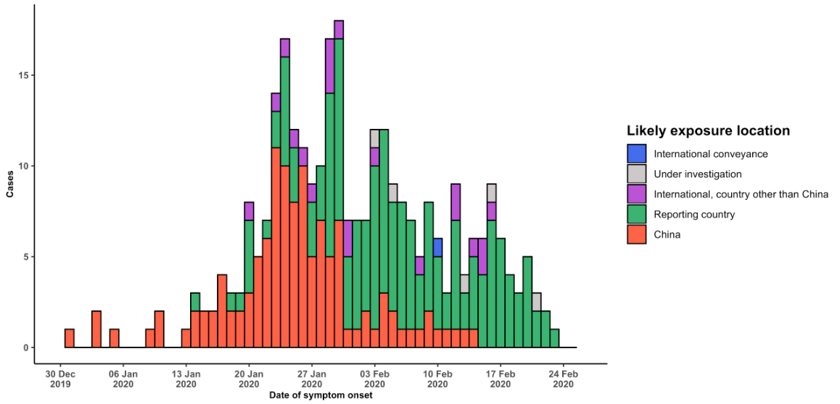
Note for figure 2: Of the 2459 cases reported outside China, 86 were detected while apparently asymptomatic. For the remaining 2373 cases, information on date of onset is available only for the 303 cases presented in the epidemiologic curve.

Figure 3. Epidemic curve of COVID-19 cases (n=2459) identified outside of China, by date of report and likely exposure location, 25 February 2020

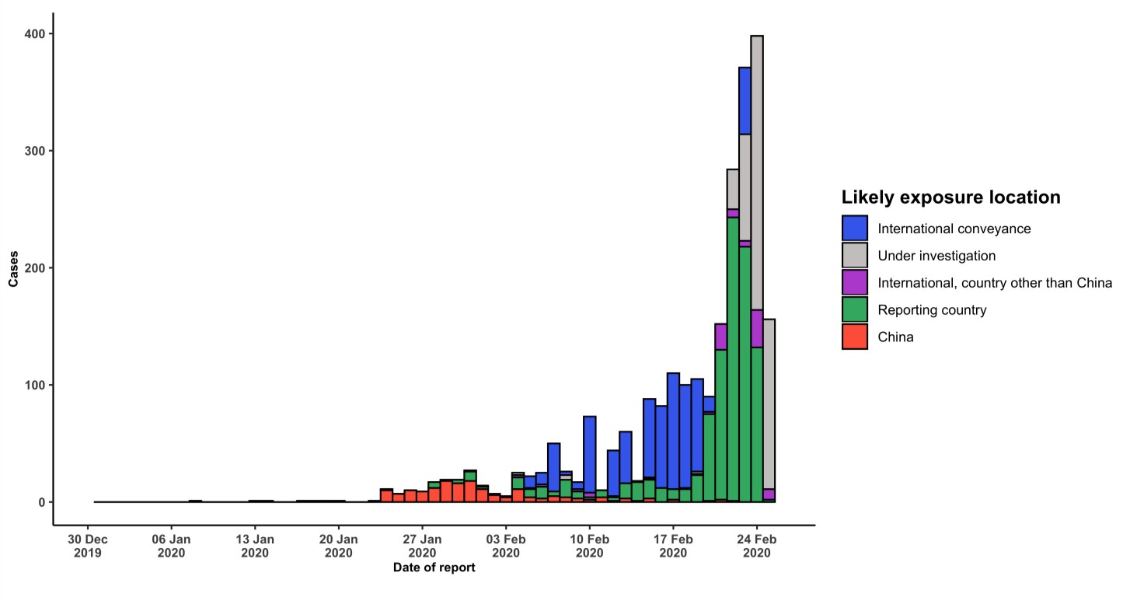
STRATEGIC OBJECTIVES

WHO’s strategic objectives for this response are to:

- Limit human-to-human transmission including reducing secondary infections among close contacts and health care workers, preventing transmission amplification events, and preventing further international spread from China*;
- Identify, isolate and care for patients early, including providing optimized care for infected patients;
- Identify and reduce transmission from the animal source;
- Address crucial unknowns regarding clinical severity, extent of transmission and infection, treatment options, and accelerate the development of diagnostics, therapeutics and vaccines;
- Communicate critical risk and event information to all communities and counter misinformation;
- Minimize social and economic impact through multisectoral partnerships.

*This can be achieved through a combination of public health measures, such as rapid identification, diagnosis and management of the cases, identification and follow up of the contacts, infection prevention and control in health care settings, implementation of health measures for travelers, awareness-raising in the population and risk communication.

PREPAREDNESS AND RESPONSE

- To view all technical guidance documents regarding COVID-19, please go to this webpage.
- WHO is working closely with International Air Transport Association (IATA) and have jointly developed a guidance document to provide advice to cabin crew and airport workers, based on country queries. The guidance can be found on the IATA webpage.
- WHO has developed a protocol for the investigation of early cases (the “First Few X (FFX) Cases and contact investigation protocol for 2019-novel coronavirus (2019-nCoV) infection”). The protocol is designed to gain an early understanding of the key clinical, epidemiological and virological characteristics of the first cases of COVID- 19 infection detected in any individual country, to inform the development and updating of public health guidance to manage cases and reduce potential spread and impact of infection.
- WHO has been in regular and direct contact with Member States where cases have been reported. WHO is also informing other countries about the situation and providing support as requested.
- WHO has developed interim guidance for laboratory diagnosis, advice on the use of masks during home care and in health care settings in the context of the novel coronavirus (2019-nCoV) outbreak, clinical management, infection prevention and control in health care settings, home care for patients with suspected novel coronavirus, risk communication and community engagement and Global Surveillance for human infection with novel coronavirus (2019-nCoV).
- WHO has prepared disease commodity package that includes an essential list of biomedical equipment, medicines and supplies necessary to care for patients with 2019-nCoV.
- WHO has provided recommendations to reduce risk of transmission from animals to humans.
- WHO has published an updated advice for international traffic in relation to the outbreak of the novel coronavirus 2019-nCoV.
- WHO has activated of R&D blueprint to accelerate diagnostics, vaccines, and therapeutics.
- WHO has developed online courses on the following topics: A general introduction to emerging respiratory viruses, including novel coronaviruses (available in French, Chinese, and Spanish); Critical Care of Severe Acute Respiratory Infections; and Health and safety briefing for respiratory diseases - ePROTECT
- WHO is providing guidance on early investigations, which are critical to carry out early in an outbreak of a new virus. The data collected from the protocols can be used to refine recommendations for surveillance and case
definitions, to characterize the key epidemiological transmission features of COVID-19, help understand spread, severity, spectrum of disease, impact on the community and to inform operational models for implementation of countermeasures such as case isolation, contact tracing and isolation. Several protocols are available here: https://www.who.int/emergencies/diseases/novel-coronavirus-2019/technical-guidance/early-investigations
- WHO is working with its networks of researchers and other experts to coordinate global work on surveillance, epidemiology, modelling, diagnostics, clinical care and treatment, and other ways to identify, manage the disease and limit onward transmission. WHO has issued interim guidance for countries, which are updated regularly.
- WHO is working with global expert networks and partnerships for laboratory, infection prevention and control, clinical management and mathematical modelling.

RECOMMENDATIONS AND ADVICE FOR THE PUBLIC

If you are not in an area where COVID-19 is spreading, or if you have not travelled from one of those areas or have not been in close contact with someone who has and is feeling unwell, your chances of getting it are currently low. However, it’s understandable that you may feel stressed and anxious about the situation. It’s a good idea to get the facts to help you accurately determine your risks so that you can take reasonable precautions. (See Frequently Asked Questions) Your healthcare provider, your national public health authority and your employer are all potential sources of accurate information on COVID-19 and whether it is in your area. It is important to be informed of the situation where you live and take appropriate measures to protect yourself. (See Protection measures for everyone).
If you are in an area where there is an outbreak of COVID-19 you need to take the risk of infection seriously. Follow the advice issued by national and local health authorities. Although for most people COVID-19 causes only mild illness, it can make some people very ill. More rarely, the disease can be fatal. Older people, and those with pre- existing medical conditions (such as high blood pressure, heart problems or diabetes) appear to be more vulnerable. (See Protection measures for persons who are in or have recently visited (past 14 days) areas where COVID-19 is spreading).

